Software Design Document

February 25, 2026

PROJECT SPONSOR


- Chris Ortiz Senior Technologist, Tools & Infrastructure
- Rex Jackson Vice President, Tools & Infrastructure

TEAM DETAILS


- Team Name: Blueprint Jacks

- Team’s Faculty Mentor: Ogonna Eli

- Team Members: Jackson Belzer, Christian Lamb, Juan José Serrano Mora, Alejandro Benito Marcos

Table of Contents
1. Introduction 3
1.1. Industry Context 3
1.2. Sponsor Overview 3
1.3. The Problem 3
1.4. Current Workflow 4
1.5. Key deficiencies 4
1.6. Overview Statement 5
1.7. Key Features 5
1.8. System Data and Workflow 5
1.9. Impact and Trade-offs 5
1.10. Alternative Approaches 6
1.11. Broader Impact 6
1.12. System Architecture Diagram 6
2. Implementation Overview 7
2.1. Introduction 7
2.2. Implementation Context and Constraints 7
2.3. High-Level System Approach 8
2.4. Key Technologies 8
2.5. Architectural Patterns and Design Rationale 9
2.6. Summary 10
3. Architectural Overview 11
3.1. Introduction 11
3.2. System Architecture Diagram 13
3.3. Architecture Description 14
3.4. Architectural Style and Rationale 15
3.5. Dependencies 16
4. Component-Level Design 18
4.1. Introduction 18
4.2. Visual Studio Code Extension 18
4.3. PlusCal to PlantUML Compiler 19
4.4. Parser 19
4.5. AST Data 20
4.6. Code Generation 21
4.7. PlantUML to PDF Generation 22
4.8 Concerns 23
5. Implementation Plan 25
5.1 Introduction 25
5.2 Development Phases/Milestones 25
5.3 Order Of Component Implementation 26
5.4 Integration and Testing 26
5.5 Risks/Mitigation 27
6. Conclusion 28

1. Introduction

1.1. Industry Context
The global data storage industry is a key pillar of the modern digital economy. As the world produces in excess of 120 zettabytes of data each year, the ongoing demand for trusted and high-performance storage solutions will only continue to grow in every sector, whether this be consumer electronics, cloud computing, enterprise servers or artificial intelligence systems. Demand for the storage device market alone was worth more than $80 billion in 2024, and it is expected to continue to grow as connected devices, edge computing, and IoT infrastructures expand around the world. The competitive and innovation-driven nature of this ecosystem demands that customers have trusted and reliable product solutions and confidence that their data will be maintained with integrity.

1.2. Sponsor Overview

Our project sponsor, SanDisk, is one of the leading developers and manufacturers of flash memory storage products in the world. As a key player in the global storage industry, SanDisk’s technologies form the backbone of many of today’s data-driven products and services. There are a variety of products in SanDisk's portfolio, including solid-state drives (SSDs), USB flash drives, memory cards, and embedded storage that are integrated into millions of devices around the world. The company generates value from consumer purchases and from its OEM partnerships, supplying storage components for smartphones, cameras, computers, and industrial systems. SanDisk has a global outreach and places high value on innovation and manufacturing excellence; therefore its business model is based on producing the highest quality and performance in its engineering and design.

1.3. The Problem

While SanDisk has introduced TLA+ and PlusCal to formally verify designs mathematically, most engineers and reviewers still rely heavily on manual visual documentation to understand system behavior. The lack of integration between formal verification tools and diagram/documentation workflows has created a significant productivity and communication gap within the company.

The fundamental challenge is a documentation process that is slow, error-prone, and detached from well-tested models, which raises the possibility that diagrams and design documents do not adequately represent the formally verified logic of the system. Consequently, design errors can propagate through review without notice.

1.4. Current Workflow

At SanDisk, the firmware engineering teams are responsible for designing, verifying, and documenting the internal logic of complex storage systems. The design of each product begins with a specification of the design concept in plain English, tables and pseudocode, as well as UML diagrams. These design documents are iteratively reviewed by engineers, quality specialists and product managers before a design is approved for implementation.
The workflow can be summarized as follows:
- Design Authoring: Engineers write the design specifications in English, including pseudocode to describe how the system is expected to behave.
- Diagram Creation: Visual documents in the form of flow charts, sequence diagrams, and activity diagrams are created manually to communicate the logic to cross-functional teams.
- Design Review: Documents and diagrams go through a review process with multiple engineers and stakeholders providing feedback through several revision cycles.
- Verification: Once the design is approved, it is internally tested, though the verification process typically does not include formal mathematical verification.
- Documentation and Distribution: The final documents are exported to PDF and distributed to teams for historical purposes and for validation by the client.

1.5. Key deficiencies
The current workflow has several critical limitations that reduce efficiency and increase the risk of errors:
- Manual and time-consuming diagram generation, which slows down design review.
- Risk of inconsistencies between the manually created diagrams and the intended system logic, since current workflows are not connected to formal verification tools like TLA+.
- Disconnected workflow, with diagrams and PDFs not automatically reflecting formally verified logic.
- Lengthy review cycles, as reviewers must interpret separate pseudocode and diagrams.
These deficiencies highlight the need for an automated system that generates accurate, synchronized diagrams and PDFs from verified PlusCal specifications, improving efficiency, accuracy, and confidence in SanDisk’s design process.

1.6. Overview Statement

P2P2P is a Visual Studio Code–integrated tool that automates documentation generation from verified PlusCal specifications. It converts these models into professional UML diagrams and complete PDF documents with minimal manual effort. This reduces time, improves accuracy, and ensures consistent documentation grounded in formally proven system behavior.
This document defines the architectural and modular design decisions that will guide the implementation of the P2P2P system and serve as a technical blueprint for development.

1.7. Key Features

The P2P2P system will provide the following core capabilities to solve the deficiencies identified in SanDisk's current workflow:
- Automated diagram generation
- Integrated VSCode extension
- Verification-first approach
- Professional PDFoutput and cross-platform compatibility.

1.8. System Data and Workflow

- Input: PlusCal .tla files verified via TLC; VSCode settings for styles and preferences
- Output: UML diagrams (PNG/SVG), PlantUML files, polished PDF for design review and project archives
- Processing: Parsing .tla files, converting PlusCal constructs to PlantUML, compiling into PDF; errors surface during diagram generation

1.9. Impact and Trade-offs

Replaces manual diagramming and PDF creation, reducing errors, shortening review cycles, and preserving knowledge. Trade-offs: PlusCal learning curve, limited PlantUML customization, and maintaining specs in PlusCal.

1.10. Alternative Approaches
Manual diagram tools, generic UML generators, and web-based solutions were rejected due to inefficiency, lack of integration, or security concerns. Monolithic TLA+ integration was deferred to simplify development.

1.11. Broader Impact
P2P2P not only solves SanDisk’s documentation issues but also lowers the barrier to adopting TLA+, encourages wider use of formal methods, and enables reusable verified PlusCal design patterns that reduce duplicated engineering effort.

1.12. System Architecture Diagram

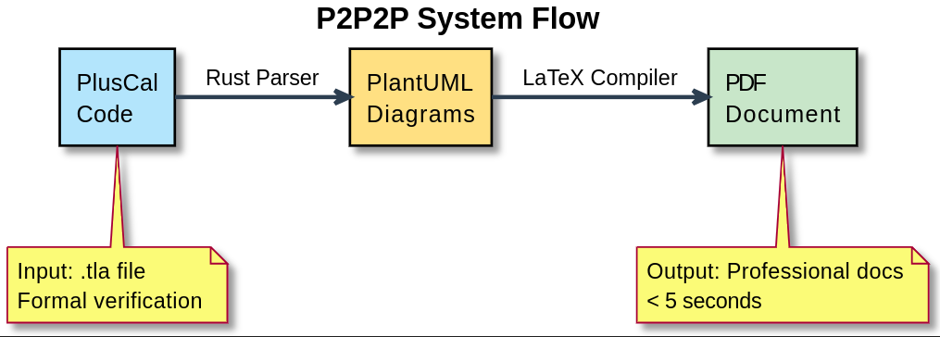

Figure 1: The diagram above illustrates the P2P2P system architecture. The yellow notes are just comments for the items that are pointing to, they are not inputs/outputs.

2. Implementation Overview

2.1. Introduction
Building on the solution vision introduced in the previous section, this project focuses on the implementation of P2P2P, a verification-driven documentation generation system designed to eliminate manual diagram creation and ensure that all design artifacts accurately reflect formally verified system behavior. The previous part of this document introduced what this system hopes to accomplish and why it is important. However, this section will describe how this system will be built from both an implementation and architectural perspective.
By providing an overview of the system’s implementation there is an opportunity to develop a general idea of how the system will be structured and implemented, the technical limitations of developing, and the principle design decisions that guide development of the system. An overview of implementation includes the constraints imposed by the need to seamlessly integrate with existing engineering workflows at SanDisk, maintain correctness of the software, and provide the same level of performance and usability as current offerings.

2.2. Implementation Context and Constraints
There are several practical and technical constraints that have influenced the architectural decisions made when implementing the P2P2P tool.

Due to the fact that Visual Studio Code is the primary development environment for engineers of firmware and verification, there are specific limitations regarding how this new system must be built. It can only use the VSCode extension framework, which will restrict all interaction with the new system via commands that can be executed within the Visual Studio Code editor. The only configuration files and artifacts generated from the system will also be created within the project workspace.

Also, the new system must use PlusCal specifications developed in TLA+ and employ the TLC model checker for formal verification, as part of the documentation workflow. By invoking verification prior to the creation of documentation artifacts, P2P2P supports a verification-enabled workflow that leverages existing TLA+ tools without requiring any new TLA+ tools to be created or built.

Another constraint is that the P2P2P system must operate locally and offline. Many companies treat their design specifications and firmware logic as proprietary information, and therefore they will not use cloud based processing to complete their designs. As a result, the decision has been made to use local tools (PlantUML and LaTeX) for generating diagrams and documentation.

The final constraint is that the P2P2P system is expected to scale to meet the needs of large, complex design specifications without introducing a significant amount of latency into the design process. This constraint is driving the use of efficient parsing, modularize processing stages and compiled tools where appropriate.

2.3. High-Level System Approach
In a broad sense, the P2P2P model uses a pipeline style of development based on transforming formally verified PlusCal specifications into visual and document artifacts that are synchronized together through each stage of the pipeline. Each stage of the pipeline has only one specific responsibility, which keeps the system modular, maintainable, and extensible.

The overall strategy is as follows:
- Gathering input from verified PlusCal (.tla) files contained in the VSCode workspace.
- Parsing the PlusCal language and semantically extracting those PlusCal constructs (that have relevance to the flow of control and behaviour of the system).
- Creating visual diagrams by converting the previously extracted semantics into PlantUML diagrams.
- Compiling documents that include the generated diagrams (and their associated metadata) based on the compiled diagrams and metadata, the final document is a polished PDF.

Each of the staged approaches allows for isolating the failure of any one of the pipeline's stages, provides for inspection of the intermediate outputs generated from any of the stages of the pipeline, and provides for minimal disruptions when adding any additional extensions to the pipeline (e.g., adding other types of diagrams).

2.4. Key Technologies

There are only a few different technologies used together to build the P2P2P architecture. All were chosen with the intention of addressing a specific need in P2P2P, as described below.

Visual Studio Code Extension (in TypeScript)
The VSCode extension is the primary user interface used to interact with P2P2P. Users will be able to set their individual P2P2P configurations, initiate documentation generation, and read error or log messages from their VSCode instance seamlessly. By embedding P2P2P into VSCode, there will be minimal to no impacts on the user’s workflow, leading to reduced barriers for adoption.

Rust-based Processing Core
P2P2P’s backend written in Rust is responsible for parsing PlusCal specifications, compiling them to a semantic model, and generating intermediate representations for diagrammatic construction. Rust is selected due to its high performance characteristics, strong safety assurances, and suitability for building reliable tools that need to handle large and/or complex inputs in an efficient manner.

TLA+ and TLC Toolchain
The system will function based on the installed ecosystems of TLC and TLA+. The output generated from the P2P2P architecture will be worked upon with the knowledge that they were previously validated using TLC. Although the P2P2P system will not directly call the model checker, it will leverage the structural and correctness guarantees provided by TLA+/PlusCal to achieve the realization of formally proven behaviour in the output generated by P2P2P.

PlantUML
The diagram generator engine is PlantUML. The system exists to produce a PlantUML source file for the purposes of transparent reproduction of diagrams and, where necessary, to allow the user the ability to modify or review the diagram. The integration of PlantUML with multiple UML diagram types delivers a clean, offline method of producing UML-based design documents.

LaTeX-based PDF Toolchain
The LaTeX toolchain will take the assembled diagrams, textual descriptions, and metadata, and create a high-quality PDF document of the designs created. This configuration will ensure consistent formatting of the designs, high-quality typography of the designs, and the design documents will have the ability to be maintained over time.

2.5. Architectural Patterns and Design Rationale

A modular, layered architecture is used for implementation in which user interaction, processing logic, and generation of artifacts are separated. This delivers lower coupling of modules and allows for independent development and testing of each subsystem.

The VSCode implementation uses a command driven interaction model, where users explicitly request generation actions instead of relying on a continuous background process. This decision avoids creating extra calculations as well as providing engineers full control over when documentation is produced.

Also, the pipeline architecture is designed with a single-source-of-truth philosophy. The verified PlusCal specification is the only authorized source for system behaviour. Artifacts generated from the PlusCal specification are generated by using this single-source-of-truth; therefore there are no points of divergence between documentation that is generated and the PlusCal specification that has been verified through testing.

2.6. Summary
This implementation overview establishes the technical framing for the P2P2P system, outlining the constraints, architectural approach, and key technologies that shape its design. By grounding documentation generation in formally verified specifications and integrating directly into existing engineering workflows, P2P2P provides a scalable and reliable foundation for the detailed design decisions presented in the sections that follow.

3. Architectural Overview

3.1. Introduction

This section describes the high-level architecture of PlusCal compiler to PlantUML, and a toolchain designed to transform PlusCal specifications into a structured technical documentation that includes multiple UML-style diagrams and a final PDF output. The architecture focuses on modularity, local execution, and clear separation of responsibilities between parsing, model representation, code generation, and documentation production.

The system is implemented as a modular monolithic application, executed entirely on the local machine, and optionally integrated into the development workflow through a Visual Studio Code extension.
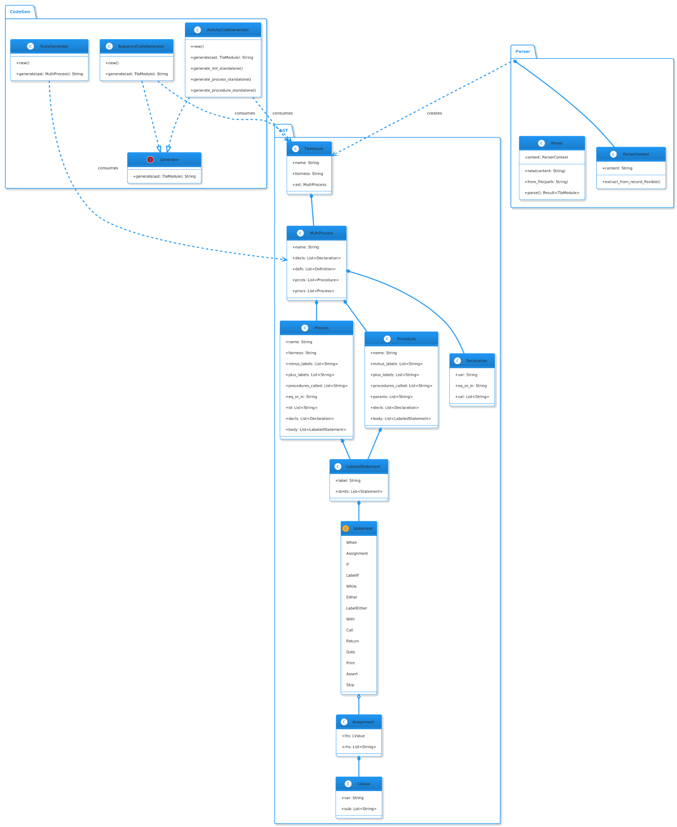

Figure 2: Class diagram describing the compiler of the P2P2P program

3.2. System Architecture Diagram

At a high level, PlusCal is structured as a processing pipeline composed of several well-defined components. Each component is responsible for a single transformation step, and all components are executed locally without network communication.

Major components:

- Visual Studio Code Extension
- Core Processing Engine
- Parser and AST Builder
- Diagram Code Generators
- Documentation Generator (PDF)
Data flow overview:

- A PlusCal specification is provided either through the CLI or the VS Code extension.
- The specification is parsed and transformed into an internal Abstract Syntax Tree (AST).
- The AST is consumed by different generators to produce PlantUML diagrams.
- Generated diagrams are composed into a technical documentation.
- A final PDF document is produced using LaTeX tooling.

External dependencies:
- TLC: used for PlusCal/TLA⁺ model checking and validation.
- PlantUML: used for generating visual representations of the system behavior.
- LaTeX: used to compile the final PDF documentation.

3.3. Architecture Description

This section describes the responsibilities of each architectural part and the way control and information flow through the system.

Core Responsibilities

- VS Code Extension
Acts as an optional frontend component that integrates PlusCal into the developer’s IDE. It allows users to trigger parsing, diagram generation, and documentation creation without leaving the editor. The extension does not contain business logic; it delegates all processing to the core engine.
- Core Processing Engine
Coordinates the execution of the pipeline stages. It is responsible for invoking the parser, selecting the appropriate generators, and orchestrating the documentation workflow.
- Parser and AST Module
Transforms PlusCal source code into a strongly typed internal AST. This AST represents processes, procedures, declarations, and statements in a structured and generator-agnostic form.
- Code Generation Modules
Consume the AST to generate different PlantUML representations (e.g., activity, sequence, and state diagrams). Each generator is independent and implements a common interface.
- Documentation Generator
Aggregates the generated diagrams and produces a final technical document, compiled into PDF format using LaTeX.
Communication and Control Flow

The architecture follows a dependency-based pipeline model. Components do not communicate synchronously at runtime, nor do they require concurrent execution. Instead, each stage depends on the artifacts produced by previous stages.

For example:

- Diagram generation cannot occur unless the AST has been successfully produced.
- Documentation generation cannot occur unless the required diagrams already exist.
However, once an artifact is generated, it can be reused at a later time. This means that:

- The pipeline does not need to be executed end-to-end in a single run.
- Individual stages may be executed independently, as long as their input artifacts are available.
This results in an asynchronous execution model in time, but a strict dependency order in terms of data and control flow.

3.4. Architectural Style and Rationale

Modular Monolithic Architecture

PlusCal is designed as a modular monolith rather than a distributed or service-based system. All components are compiled and executed as part of a single application, but internal modules are strictly separated by responsibility.
Rationale:

- The system is intended for local execution and academic usage.
- There is no need for network communication or service orchestration.
- A monolithic structure simplifies deployment, testing, and debugging.
This approach was preferred over a microservices architecture, which would introduce unnecessary complexity without providing tangible benefits for the intended use case.
Extension-Based Architecture
The Visual Studio Code extension is treated as an external integration layer rather than a core component. This allows PlusCal to be used both as a standalone CLI tool and as an IDE-integrated solution.
Rationale:
- Keeps the core system independent from any specific editor.
- Enables future integrations with other development environments.
Pipeline Processing Model

The system follows a transformation pipeline:

PlusCal Source → AST → Diagrams → Documentation → PDF

Each stage is isolated and consumes only the output of the previous one.
Rationale:
- Encourages clear responsibility boundaries.
- Allows reuse of intermediate artifacts.
- Simplifies extension of the system with new generators

3.5. Dependencies

Plaskal relies on a small number of external tools, all used locally:

- TLC (TLA⁺ Model Checker)
Used to validate PlusCal/TLA⁺ specifications before or during processing.
- PlantUML
Used as the target language for diagram generation, enabling consistent and reproducible visual outputs.
- LaTeX

Used for high-quality PDF generation, allowing the final documentation to follow academic and technical standards.
In addition, the architecture includes an AI-based assistant module for documentation support. This component is designed to be provider-agnostic and replaceable, allowing future integration of different AI solutions without impacting the core architecture.

4. Component-Level Design

4.1. Introduction

The P2P2P program contains several different components that make it work, from the high level overview, to a more in depth look at the pieces. Here, we are going to go over the pieces of the system and through this component overview, it will give a good idea of the overall structure and functioning of the program, as well as the interconnectedness of the different components.

4.2. Visual Studio Code Extension

The Visual Studio Code extension exists as a way for the user to interact with the system as a whole. It is responsible for calling the programs that achieve the different jobs required by the system, such as verifying a model and generating a diagram for that model, and automatically creating a PDF from those diagrams.

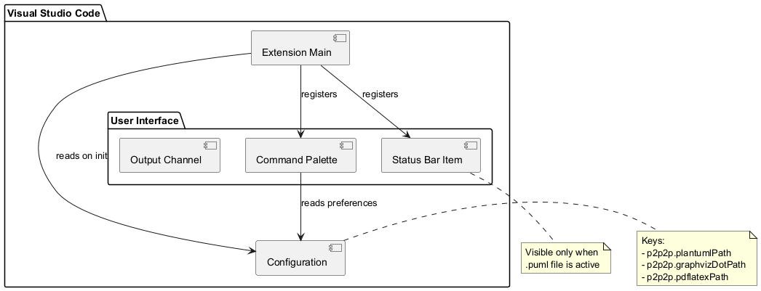

Figure 3: Component diagram describing the Visual Studio Code Extension of the P2P2P program

Public Interface:
- Commands: Verify and Output Model Diagram, Export PDF.
- Configuration: Allows the user to change configuration settings that will affect the way that the program will run, like important file paths for external tools needed for execution.
- Events: Listens for if the active page of the user changes to evaluate whether it should display certain UI elements that make using the program easier.
Interactions:
- Calls the PlusCal to PlantUML compiler.
- Calls the PlantUML to PDF generator.

4.3. PlusCal to PlantUML Compiler

The PlusCal to PlantUML Compiler is responsible for taking in a PlusCal model, verifying the model with the TLC automatically, and parsing that AST to generate a diagram of various types, including activity, sequence, and state diagrams. This is the first high level processing step that is required for the system to work.

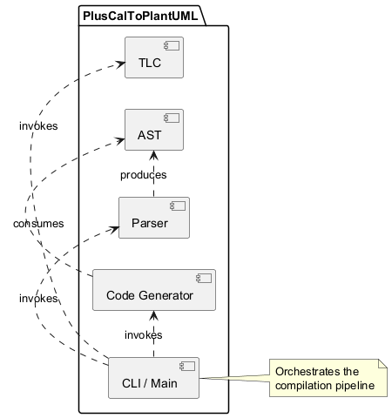

Figure 4: Component diagram describing the compiler step of the P2P2P program

Public Interface:
- Commands: Called in different modes according to the diagram desired, and the input and output file names.
Interactions:
- The Visual Studio Code extension directly interacts with this as a part of its pipeline.
- Interacts with the Parser to gather information in a usable format from the program AST.
- Uses the AST data structure returned by the Parser, and passes that information to the Code Generator.

4.4. Parser

The Parser is responsible for the syntactic analysis of the AST file generated by the PlusCal file given, and creating a data structure that is simple to navigate and interpret for the code generation step. This is a key part of translating the initial PlusCal model into the final diagram, and without it there would be no data to work off of for generating the final PlantUML code.

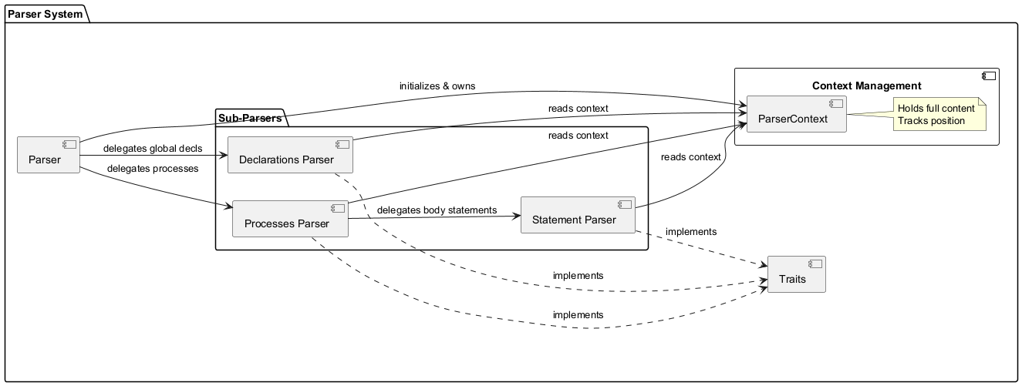

Figure 5: Component diagram describing the parser step of the P2P2P program

Public Interface:
- Parser::new(content: String) -> Parser: Initialize a new Parser with string content.
- Parser::from_file(path: &str) -> Result<Parser, Error>: Method of creating a parser from a file path.
- parse(&self) -> Result<TlaModule, String>: This is the entry point for parsing the AST file once you have created a parser, and this function is responsible for using the AST data structure and populating it with the information found within the given AST file.
Interactions:
- The main PlusCal to PlantUML component uses this for the parsing step.
- Uses the AST data structure to contain collected information.

4.5. AST Data

The AST component serves as the central data structure for information being passed from the parsing step of the system to the code generation step of the system. It does not contain logic for running a process, but it does define a structural data type that decouples the Parser from the Code Generator.

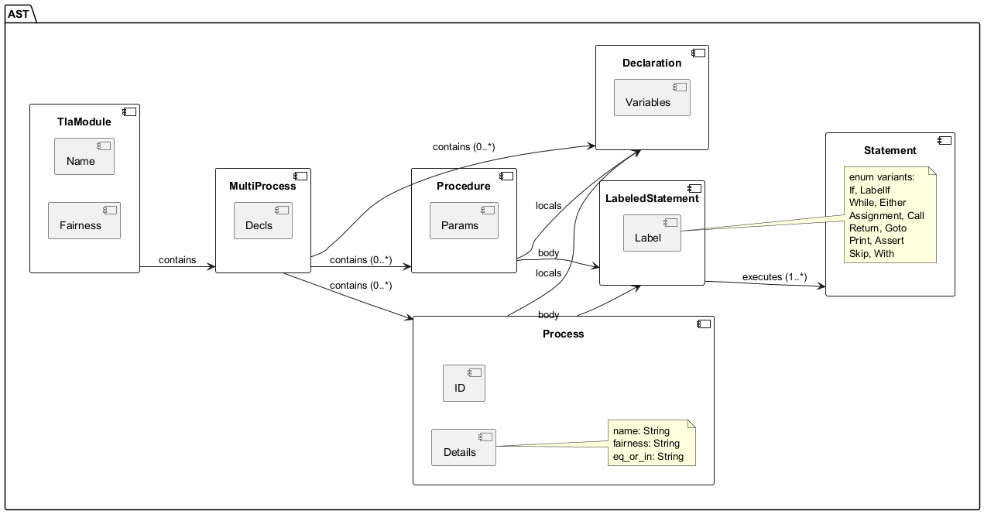

Figure 6: Component diagram describing the AST data collected by the P2P2P program

Public Interface:
- Exposes public data structures like TlaModule, Process, and Statement to the overall system for use and processing.
Interactions:
- Created by Parser.
- Consumed by Code Generator.

4.6. Code Generation

The Code Generation component handles the transformation of the internal AST into specific visual diagrams. It encapsulates the logic for visual layout, PlantUML syntax rules, and diagram-specific conventions. It is the final stage of the compiler pipeline.

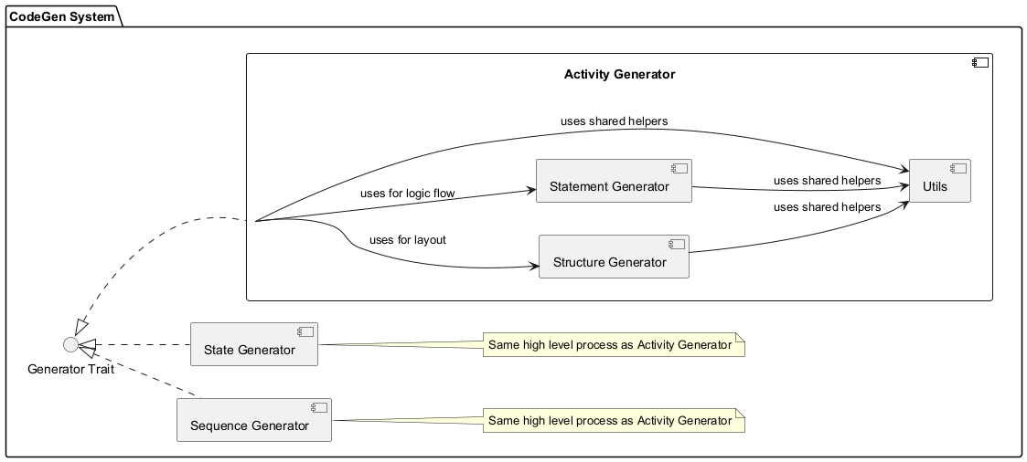

Figure 7: Component diagram describing the code generation step of the P2P2P program

Public Interface:
- ActivityCodeGenerator::new() -> Self: Creates a new instance of the activity diagram generator.
- SequenceCodeGenerator::new() -> Self: Creates a new instance of the sequence diagram generator.
- StateGenerator::new() -> Self: Creates a new instance of the state diagram generator.
- generate(&self, module: &TlaModule) -> String: The core method implementing the Generator trait. It takes the full AST and returns the complete PlantUML source code string.
Interactions:
- This is used by the main PlusCal to PlantUML program and called upon based on the input diagram type it is given.

4.7. PlantUML to PDF Generation

The PlantUML to PDF Generator is responsible for collecting the completed diagram output from the initial PlusCal to PlantUML step and compiling it into a final document that is ready to be shipped and protected from tampering. The formatting of this final document is determined by the provided formatting file.
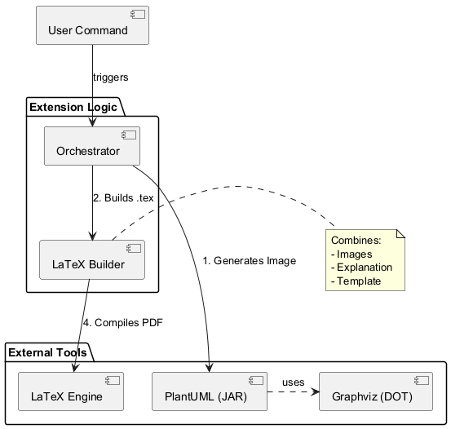

Figure 8: Component diagram describing the PDF generation step of the P2P2P program

Public Interface:
- generatePdf(pumlPath, …): The main entry point invoked by the command handler.
- Takes the Source.puml file path, and configuration settings as inputs.
- Outputs the final PDF file at the same location as the source.
Interactions:
- Is only called by the Visual Studio Code extension once the previous steps in generating the diagrams is completed.

4.8 Concerns

Reliance on External Tools:

Due to the relatively significant amount of external tools that are being relied upon for the project to remain functional, it is important to keep in mind that if those tools lose support or get deprecated over time, changes to the dependencies or the development of new independent tools might be required.

Separation of Concerns:

While the program as a whole is designed in a way that is modular and splits tasks into discrete and separated parts of the program, and generally this would help with development because it is easier to modify only the parts you need to, it can lead to unintended problems down the line. For example, making the code too separated from each other, can make the development of more significant changes difficult due to the larger number of files to navigate, the increased cognitive load to be able to navigate long chains of side effects through files, and complex dependencies. In the current state and current design, it would be reasonable to say that this is not an issue yet, but in the development of the project it is important to keep in mind that dividing the system among too many files, or making chains of logic too difficult to follow through the pursuit of modularity and separation, can make further development more challenging if taken too far.

Performance Challenges:

Given the fact that the program needs to run the TLC each time that a model is attempted to be made into a diagram, this can be a significant waste of time to developers if the models are sufficiently large, and the computational power of the device is too low. If it is a strict requirement to rerun the TLC each time a model is made, it could reduce the productivity of the tool significantly, and it could also make the chain of actions of turning those diagrams into a PDF more time consuming than it should be. It could become important to cache the results of previous tests so that the TLC is not required to run additional times on models already verified.

5. Implementation Plan

5.1 Introduction

For our implementation plan, we have our development split into different sections, each with their own requirements to be considered completed and satisfactory, working our way through multiple demonstrations of capabilities before making it to the final acceptance. Working through these stages, we have each of the tasks within the sections split among the team to maintain efficient work and make sure that we are not wasting development time waiting for other functionality to be finished if that is not required.

5.2 Development Phases/Milestones

- Phase 1: Alpha Demo I: Delivers the full workflow: VS Code commands, verification, activity diagram generation, and PDF export.

- Phase 2: Alpha Demo II: Expands functionality with sequence/state diagrams, readability improvements, and PDF provenance (hash/verification evidence).

- Phase 3: Acceptance Demo: focuses on polish: template-driven PDFs, auto descriptions, and performance/caching, followed by final stabilization.

- Parallel Work: To Keep progress moving, we will run some tasks in parallel whenever possible. During Phase 1, we can divide and concur between the VS Code UI and the actual verification/parsing foundation. In Phase 2, the sequence and state diagrams can be developed alongside readability improvements and PDF improvements. Finally, in Phase 3, PDF templates and AI descriptions can work alongside performance work and stabilization testing.

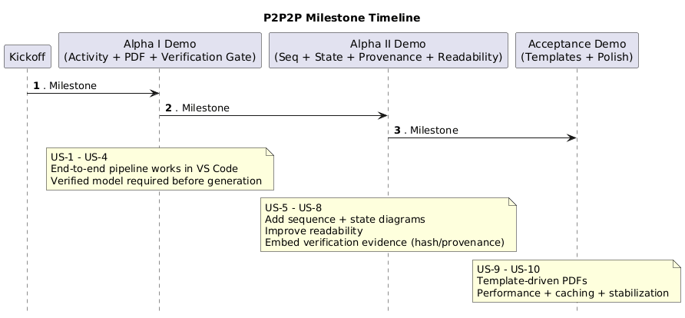
Figure 9: Timeline of the P2P2P program development

5.3 Order Of Component Implementation

We implement the pipeline in order so each stage can be tested by itself before the full integration for Alpha Demo 1.

- VS Code extension layer: commands, settings, workspace outputs
- Verification controller: blocks generation unless verified, stores verification evidence
- Parse the PlusCal/TLA+ and build semantic IR
- Diagram generators: activity (Alpha I), then sequence/state (Alpha II)
- Render + export: PlantUML to images and LaTeX to PDF
- Polish features: provenance, templates, descriptions, performance/caching

5.4 Integration and Testing

Stage 1: Verification (pass/fail + logs):

First we prove the model is correct by running TLC.

- Pass/fail = did it verify successfully or not?
- Logs = the detailed “receipt” that shows what TLC did and any errors it found.
- If verification fails, we stop here so we don’t generate diagrams from a broken or untrusted model.

Stage 2: Parse + semantic IR:

Next we read the PlusCal/TLA+ file and convert it into a structured format.

- Semantic IR (Intermediate Representation) is basically a clean, organized model of what our program does, instead of just raw text.

Stage 3: IR to PlantUML text:

Then we take that structured internal model and write PlantUML code from it.

- PlantUML is just a text language that describes diagrams.
- The output here is a .puml file (plain text).

Stage 4: PlantUML to PNG rendering:

Now we take the .puml text and ask PlantUML to draw it.

- PNG = image file

So this stage produces the actual diagram png files.

Stage 5: LaTeX assembly to PDF export:

Finally we build the PDF:

- LaTeX is a document tool that produces clean PDFs.
- “Assembly” just means to just put together the: title page, sections, captions, verification info, and the diagrams into a final document.
- Output = final PDF export.

5.5 Risks/Mitigation

- Config risk (PlantUML/LaTeX/Java/TLC): mitigate with a dependency check command and clear error messages.

- Scalability/performance on larger models: mitigate with caching by file hash and incremental rebuild for each pipeline stage.

- Readability vs correctness trade-off: mitigate by offering a “raw” mode and a “readable” mode with traceability back to IR.

- Verified P2P2P generation: mitigate by adding hashes and verification evidence into the PDF output.

6. Conclusion
This document provides a software design and an architectural guide to the P2P2P verification-based documentation generation system developed in conjunction with SanDisk. The P2P2P tool was built to fill a void in an ever-expanding industry worried about data reliability, especially concerning the issues between formally verified system behaviour and manual documentation processes that are subject to human error.

SanDisk’s deployment of TLA+ and PlusCal for formal specification and verification demonstrate their commitment to producing defect-free products with sound engineering principles. However, the lack of any automation between the verification and documentation processes leaves both processes inefficient, with an increased amount of time spent on documentation review and creating opportunities for divergence between the verified behaviour of the system and the intent of its communicated design. P2P2P directly targets these issues by converting verified PlusCal specifications into synchronised UML (Unified Modelling Language) diagrams and professionally produced (PDF) documents, thus ensuring that the documentation reflects the formally checked behaviour of the system.

A solid and feasible design solution has been developed for this problem, and this document identifies the features of the design that contribute to the solution. The primary features include a VSCode user interface integrated into the larger context of existing user workflows, a modular pipeline architecture, and the selection of well-established technologies (TLC, Rust, PlantUML, and LaTeX) to achieve an appropriate balance of correctness, performance, and usability. All of these components, together, constitute a singularly cohesive system that can practically meet the needs of an engineering organization operating in a real-world environment.

Significant progress has already been made on the system architecture, major component identification, their respective responsibilities, and developing the staged implementation plan with well-defined milestones. By implementing using a phased approach, the functionality provided by the system can be incrementally validated and risk and complexity managed. This structured approach provides a sound basis for the successful execution of the project and allows for continuous improvement of the tool as it is developed.

The overall design is intended to create a sound starting point for the successful implementation of P2P2P to create actual value for SanDisk. Reducing the amount of manual effort, improving the accuracy of documentation, and providing a validation-enabled workflow will all contribute to higher quality design reviews and greater confidence in system development. The design choices made in this document provide the basis for successful implementation, as well as a clear path towards accomplishing the project's technical and business goals.

